Week 2 Task: Advanced Data Visualization & Storytelling Report
Author: Nune Venkata Yasasvi
Role: Data Science Intern
Dataset: Expanded Titanic Survival Dataset
-----------------------------------------------------------------

1. Executive Summary & Narrative Context
This visual narrative explores the key determinants of survival on the Titanic. By utilizing advanced multi-dimensional visualizations, the analysis communicates critical insights regarding socio-economic privilege, demographic prioritization, and family structures to non-technical stakeholders.

2. Visual Data Storytelling (5 Advanced Visualizations)

Visual 1: Demographic Age & Fare Density Analysis
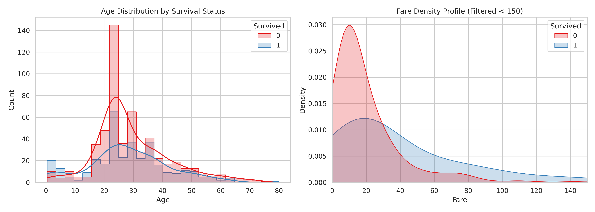
Narrative Insight: Children had prioritized survival access, whereas higher fare payers showed much broader survival density.

Visual 2: Class & Gender Interaction Matrix
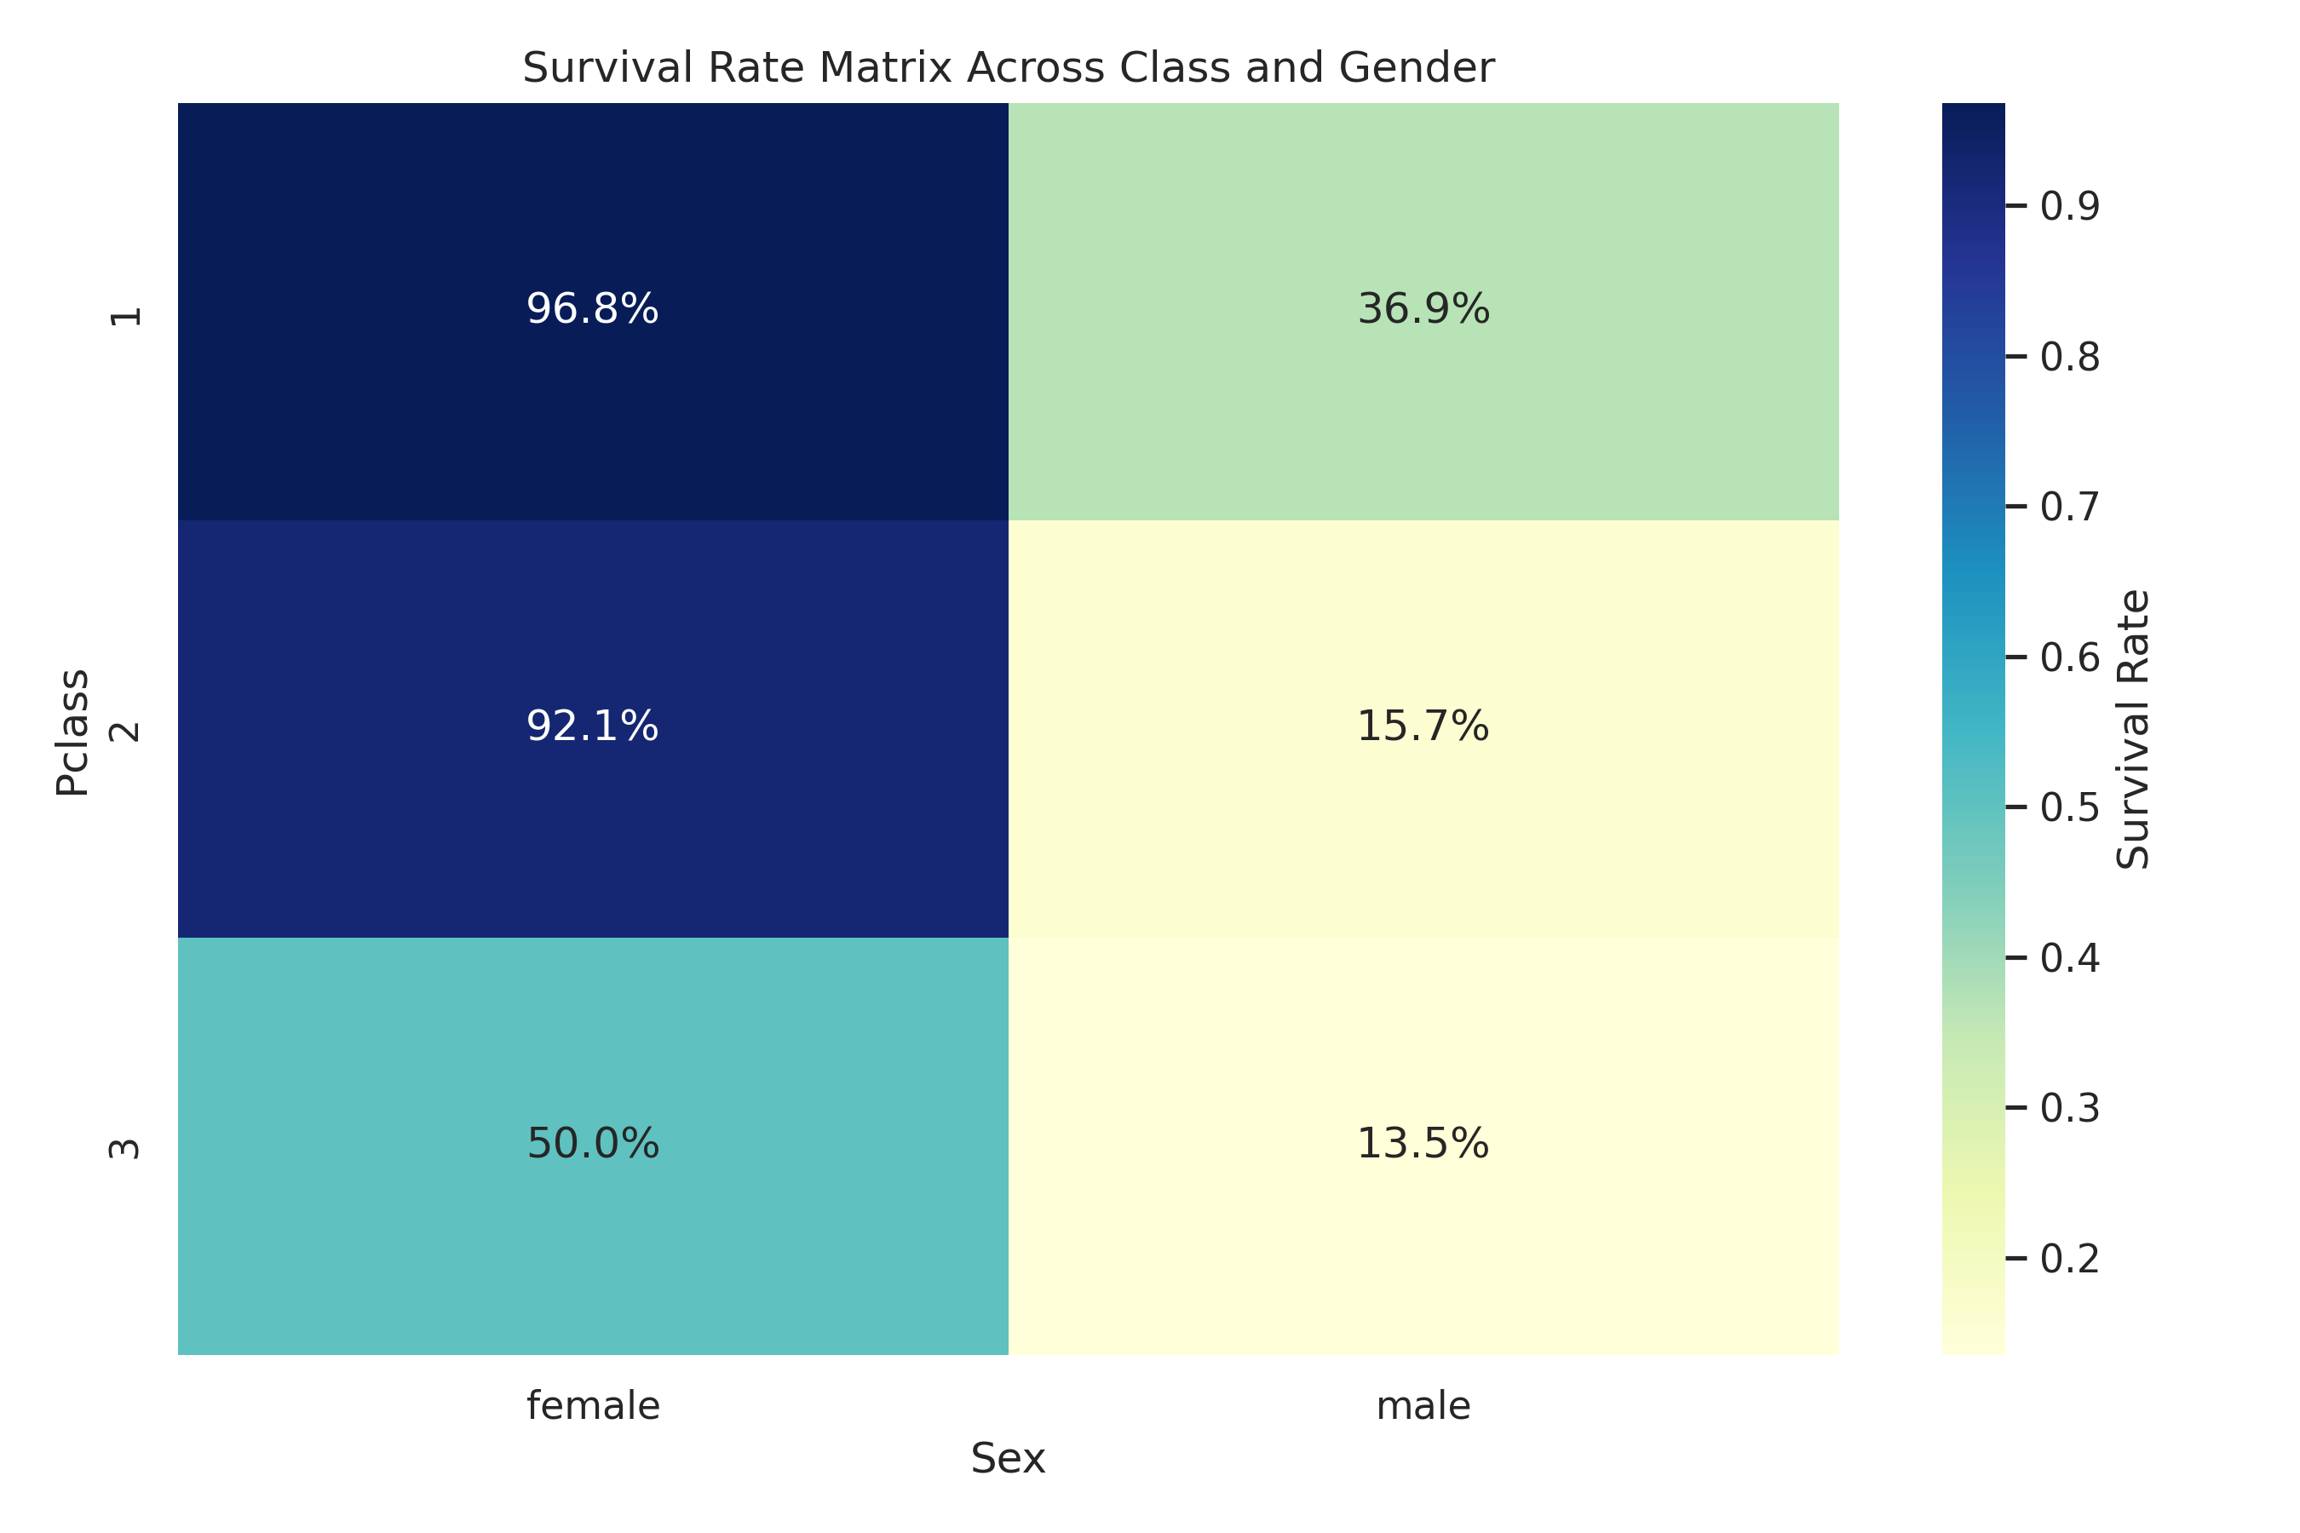
Narrative Insight: Demonstrates the 'women and children first' protocol alongside clear first-class privilege.

Visual 3: Multi-Faceted Embarkation & Socio-Economic Analysis
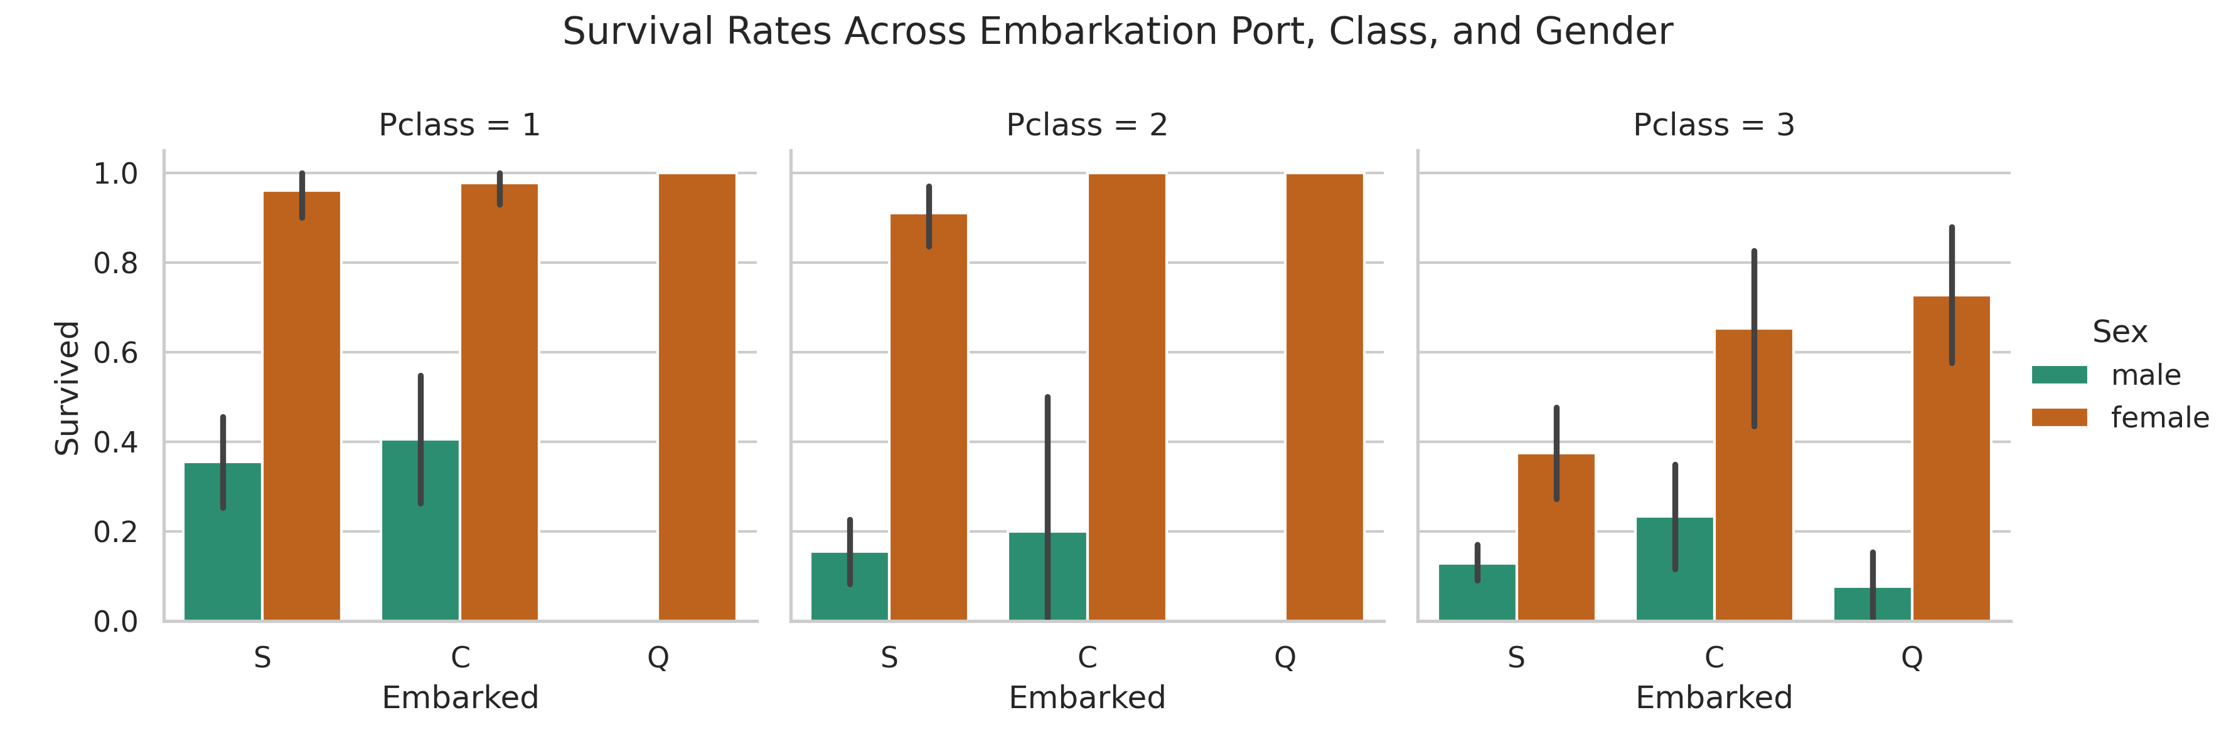
Narrative Insight: Passengers embarking from Cherbourg (C) consistently held higher survival odds due to higher representation in Pclass 1.

Visual 4: Family Dynamics & Age Stratification
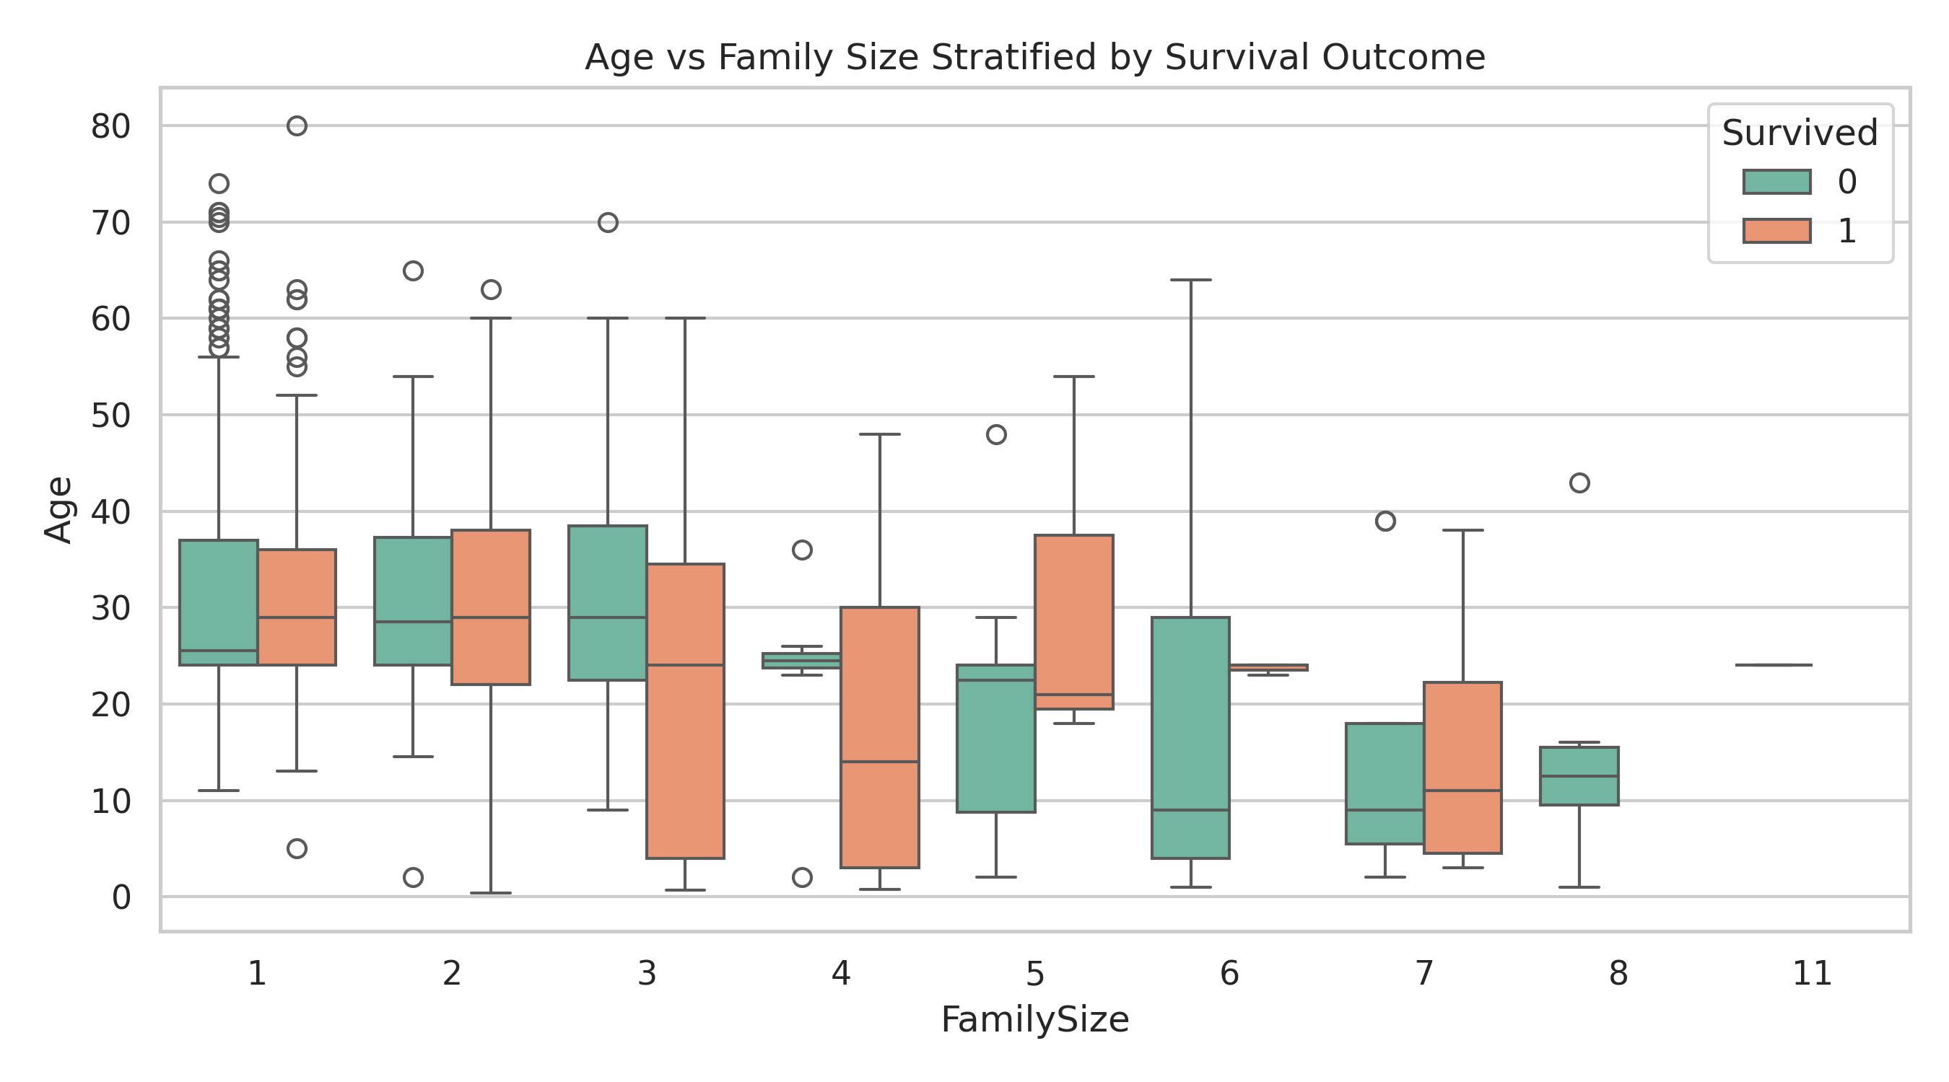
Narrative Insight: Small family units (2-4 members) exhibited higher survival rates than individuals traveling alone or large family groups.

Visual 5: Full Correlation Matrix
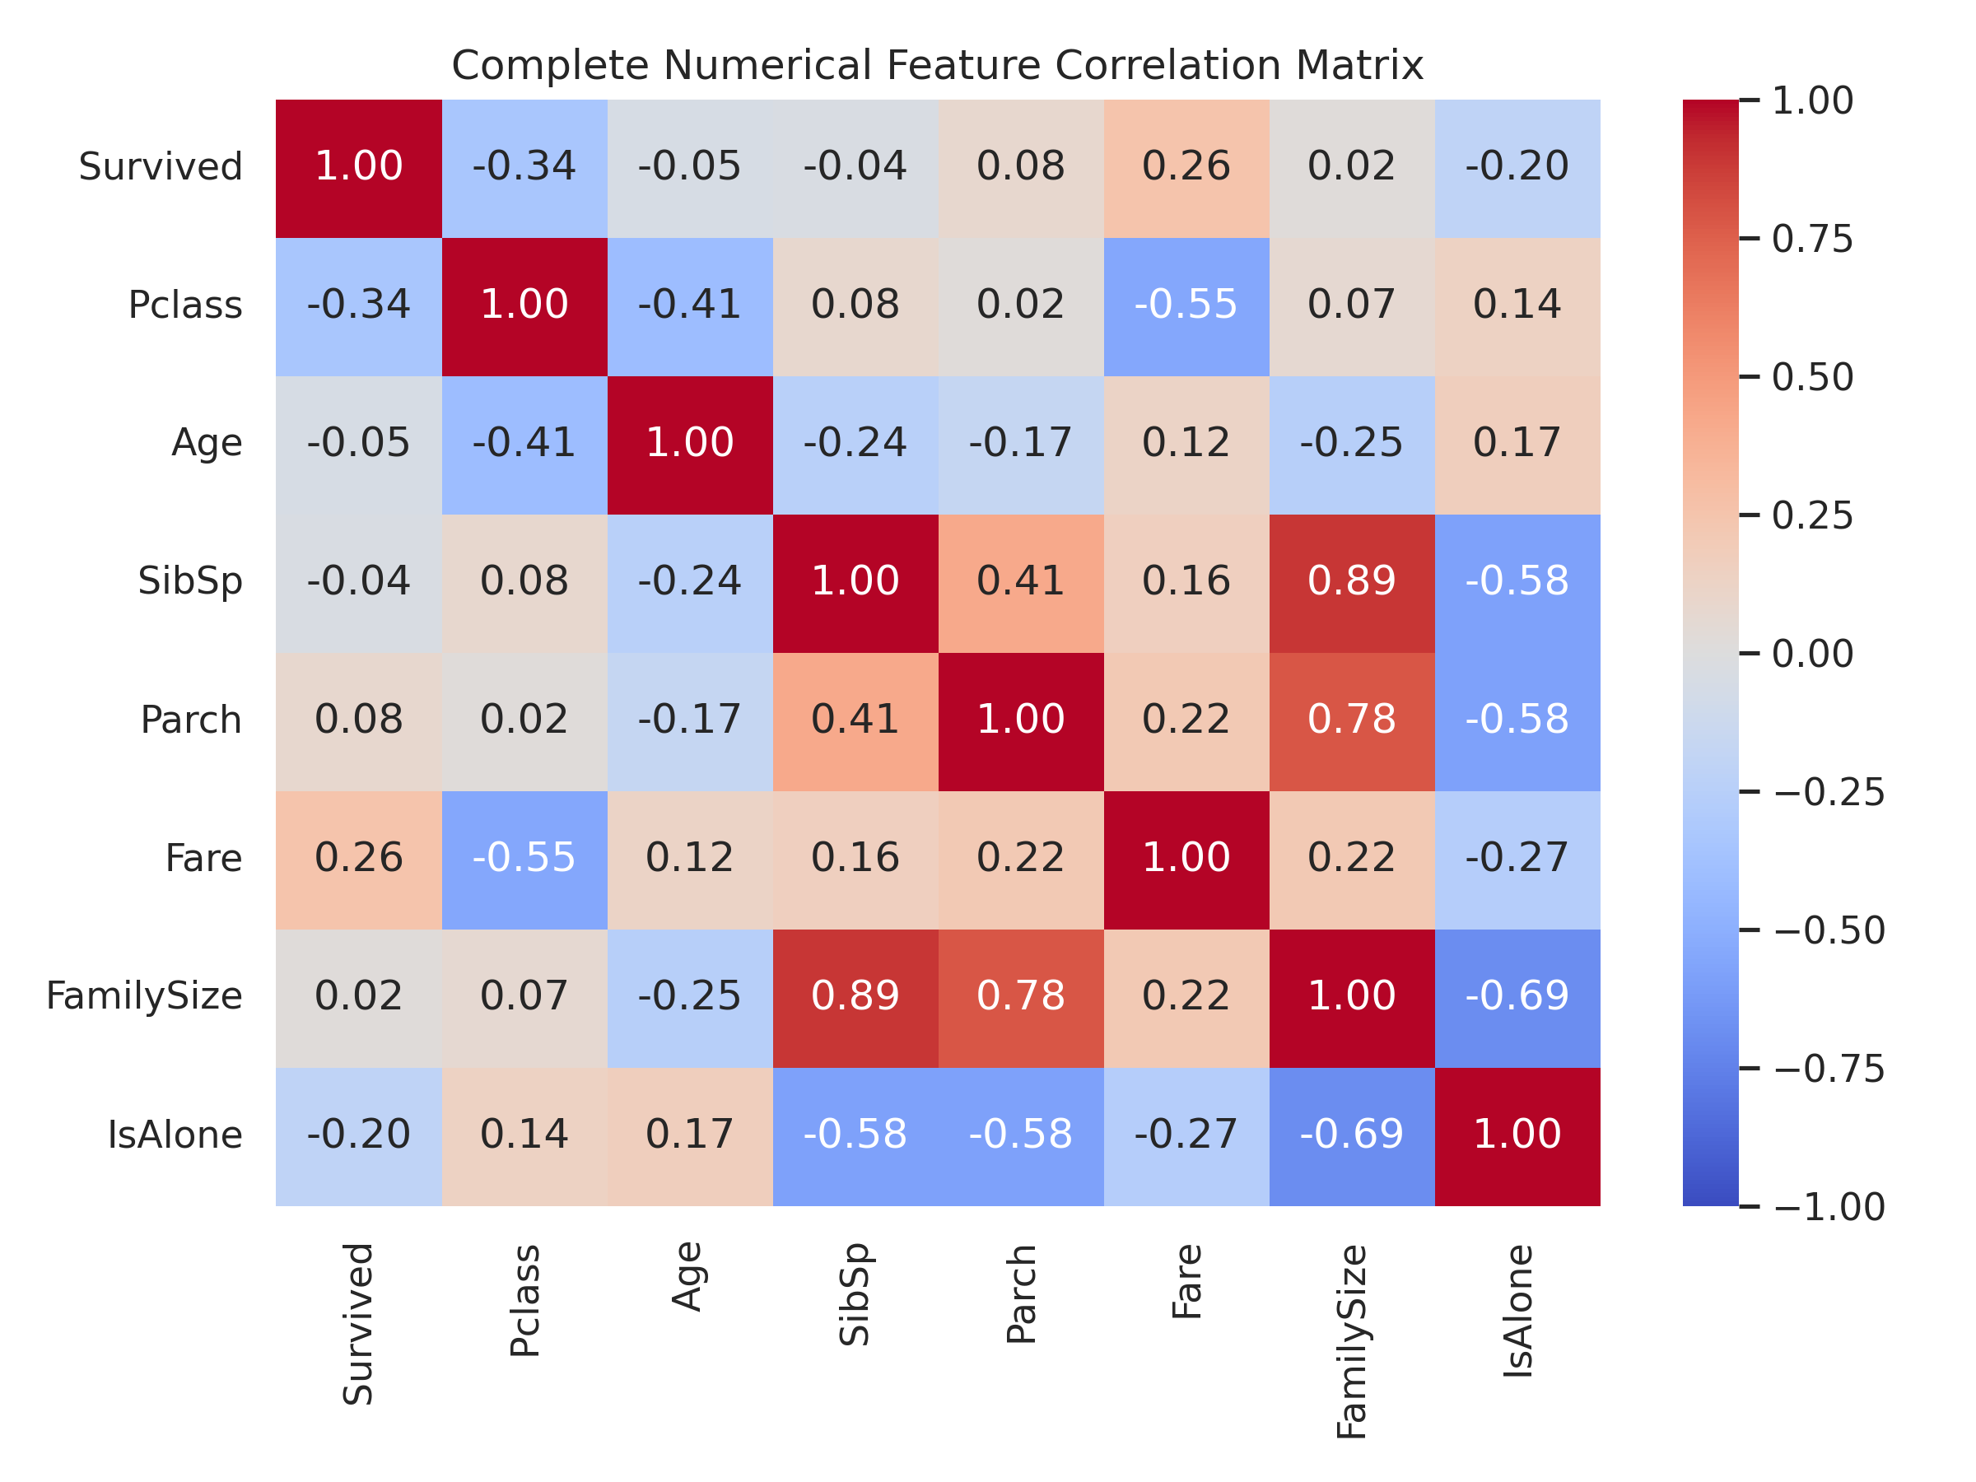
Narrative Insight: Identifies key numerical drivers of survival, highlighting strong inverse correlation with Pclass and positive correlation with Fare.

3. Business & Risk Management Implications
- • Emergency Protocol Design: Prioritization rules heavily impact evacuation safety outcomes during critical events.
- • Socio-Economic Allocation: Resource access directly affects survival probability during crisis management.
- • Group Dynamics: Traveling in moderate family groups improves evacuation efficiency compared to single passengers.

